**Vet World**

A Dissertation submitted

for the partial fulfillment of the degree of

**Bachelor of Engineering in**

**Information Technology**

**(Session 2023 - 2024)**

**Guided By: Submitted By:**

**Mr. Shyam Maheshwari Nishi Vitalkar (20I7038)**

**Saksham Gupta (20I7050)**

**Yashraj Bhargava (20I7070)**

**Department of Information Technology**

**Institute of Engineering & Technology**

**Devi Ahilya Vishwavidyalaya, Indore (M.P.)**

**(**[www.iet.dauniv.ac.in](http://www.iet.dauniv.ac.in/)**)**

**November 2023**

**Dissertation Approval Sheet**

The dissertation entitled **“Vet World”** submitted by **Nishi Vitalkar, Saksham Neekhra, Yashraj Bhargava** is approved as partial fulfillment for the award of **Bachelor of Engineering in Information Technology** degree by **Devi Ahilya Vishwavidyalaya, Indore**.

**________________ _________________**

**Internal Examiner External Examiner**

___________________________________

**Director**

**Institute of Engineering & Technology**

**Devi Ahilya Vishwavidyalaya,**

**Indore (M.P.)**

**Recommendation**

The dissertation entitled **“Vet World”** submitted by **Nishi Vitalkar, Saksham Gupta, Yashraj Bhargava** isa satisfactory account of the bonafide work done under my supervision is recommended towards the partial fulfillment for the award of **Bachelor of Engineering in Information Technology** degree by **Devi Ahilya Vishwavidyalaya, Indore.**

**Date: Mr. Shyam Maheshwari**

Project Guide

**Endorsed By: Dr. Vrinda Tokekar**

**Department of Information Technology**

**Candidate Declaration**

We hereby declare that the work which is being presented in this project entitled Vet World in partial fulfillment of degree of Bachelor of Engineering in Information Technology is an authentic record of our own work carried out under the supervision and guidance of **Mr. Shyam Maheshwari**, **Lecturer** in Department of **Information Technology**, Institute of Engineering and Technology, Devi Ahilya Vishwavidyalaya, Indore

We are fully responsible for the matter embodied in this project in case of any discrepancy found in the project and the project has not been submitted for the award of any other degree.

**Date:**

Nishi Vitalkar

Saksham Neekhra

Yashraj Bhargava

**ACKNOWLEDGEMENTS**

The satisfaction and euphoria that accompany the successful completion of any task would be impossible without the mention of the people who made it possible, whose constant guidance and encouragement crowned our efforts with success.

We express our gratitude to **Mr. Shyam Maheshwari**, our project guide, for constantly monitoring the development of the project and setting up precise deadlines. His valuable suggestions were the motivating factors in completing the work. He has taught us the methodology to carry out the project and to present the project works as clearly as possible. It was a great privilege and honor to work and study under his guidance. We are extremely grateful for what he has offered us. We express our warm and sincere thanks for the encouragement, untiring guidance, and confidence he had shown in us.

We have great pleasure in expressing our deep sense of gratitude to **Dr. Sanjeev Tokekar, Director of the Institute of Engineering and Technology** for providing the necessary infrastructure and creating a good environment.

We would also like to thank **Dr. Vrinda Tokekar, Head of the Department of Information Technology**, for her constant support.

Finally, a note of thanks to the teaching and non-teaching staff of the Department of Information Technology, for their cooperation extended to us, who helped us directly or indirectly in the course of the project work. We would also like to thank our parents, who have always been supportive and have always believed in us.

**ABSTRACT**

The modern era demands enhanced convenience and efficiency, particularly in the realm of pet healthcare. The existing landscape of veterinary services faces challenges including disjointed solutions, inefficient appointment management, inaccessible medical records, and a lack of automation for vaccination and wellness evaluations. To address these issues comprehensively, we propose a unified web application built on the MERN stack.

Our project simplifies pet healthcare by seamlessly integrating appointment management, medical records, telemedicine, and educational resources for pet owners. Users can register, schedule appointments, manage pet health records, and access vaccination information. Through this initiative, pet owners can actively participate in their pet's health management, while clinics and veterinarians can streamline operations.

The project excels over existing solutions by offering a unified experience that reduces scheduling conflicts, automates vaccine management, and empowers pet owners to make informed decisions. It stands as a step forward in revolutionizing pet healthcare by making it efficient, user-centric, and accessible.

Through the development of this platform, we've gained valuable insights into web application development, database design, and system architecture. However, our project currently lacks video conferencing integration for telemedicine, and data security will require continuous monitoring for potential vulnerabilities. Future expansions may include incorporating video conferencing capabilities and AI-based diagnostic tools.

In summary, our project aims to transform the landscape of pet healthcare, simplifying processes and empowering pet owners, while setting new industry standards in the veterinary services domain.

**TABLE OF CONTENTS Page No**

**Dissertation Approval Sheet ii**

**Recommendation iii**

**Candidate Declaration iv**

**Acknowledgements v**

**Abstract vi**

**Chapter 1 Introduction**

1.1Overview and issues involved 9

1.2 Problem Definition 9

1.3 Proposed Solution 9 **Chapter 2 Literature Survey**

2.1Methodology 11

2.2 Existing Solutions 12

**Chapter 3 Analysis & Design**

3.1 Software Requirements 15

3.2 Hardware Requirements 15

3.3 Analysis Diagrams 16

3.4 Design Diagrams 17

**Chapter 4 Implementation and Testing**

4.1 Database Design 20

4.2 Class diagram . 22

4.3 Test Cases 23

**Chapter 5 Conclusion**

**References**  27

**Chapter-1 Introduction**

* 1. **Overview and issues involved**

The modern world demands convenience and efficiency, even in the domain of pet healthcare. However, the current landscape of veterinary services faces significant challenges, primarily characterized by fragmented and disjointed solutions. There is a pressing need to address issues related to appointment management, medical record accessibility, and timely vaccination and wellness evaluations for pets. Traditional methods are time-consuming, error-prone, and often leave pet owners and veterinary clinics overwhelmed with administrative tasks. These issues underscore the need for a unified, user-centric platform that seamlessly integrates appointment management, medical records, telemedicine capabilities, and educational resources for pet owners. The solution should not only streamline processes but also empower pet owners to take proactive measures in their pet's health.

* 1. **Problem definition**

The project aims to tackle the prevalent issues in the veterinary services domain by developing a comprehensive and user-friendly web application. The primary problems to be addressed include:

* Disjointed Solutions: Existing solutions, such as veterinary clinic management software, telemedicine platforms, and pet wellness apps, operate independently, leading to fragmented pet care.
* Appointment Management: Challenges in efficiently scheduling and managing appointments, resulting in delays and scheduling conflicts.
* Medical Record Accessibility: Difficulty in accessing and updating pet health records, leading to inefficiencies and potential errors in healthcare.
* Vaccine and Wellness Management: Lack of automation for timely vaccination and wellness evaluations, putting pet health at risk.
* Proactive Pet Healthcare: A need to empower pet owners to take a more active role in their pet's health and make informed decisions.

* 1. **Proposed solution**

Our solution envisions a unified pet healthcare platform built on the MERN (MongoDB, Express.js, React, Node.js) stack. This innovative platform will address the identified issues in the **Fig. 1-1** in following ways:

**Flow Diagram:**

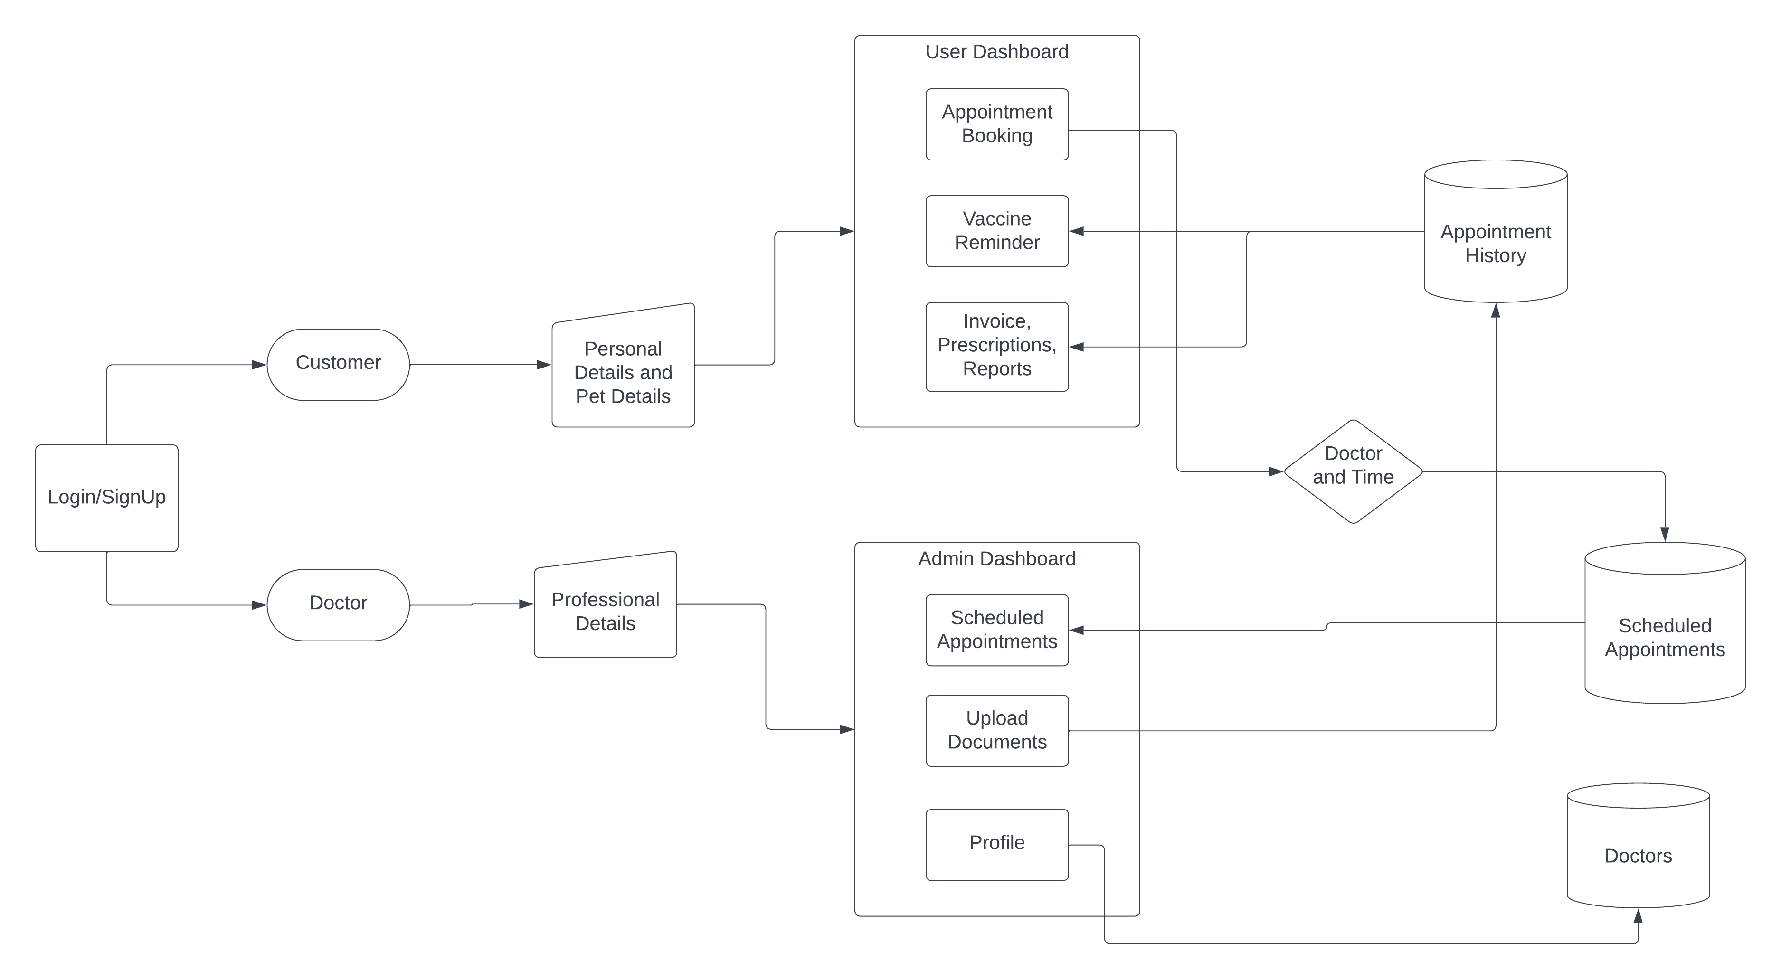

Fig.1-1: Flow diagram of the website

**Functionalities**:

* User Authentication System: A secure system to manage user profiles and access to the platform.
* Appointment Scheduling Engine: Real-time appointment scheduling with automated availability checks.
* Vaccine Management and Automation: Storage of vaccination records and automated vaccine date generation.
* Electronic Health Records (EHR): Structured and efficient storage and management of pet health records.
* Responsive Design: Ensuring a seamless user experience on various devices.
* Security Protocols: Incorporating security measures to protect user data.

**Justification**:

Our project excels over existing solutions by seamlessly integrating all essential functionalities. It streamlines administrative tasks for both pet owners and clinics, reducing scheduling conflicts, and automating vaccine management. The user-centric platform empowers pet owners in proactive pet healthcare management, setting new industry standards through technological innovation and expertise. Unlike other solutions, it offers a unified experience that simplifies pet care, promotes well-informed decisions, and contributes to the well-being of pets. In summary, our project is a step forward in revolutionizing pet healthcare, making it efficient, convenient, and user-oriented.

**Chapter-2 Literature Survey**

* 1. **Methodology**

The methodology for achieving the objectives of this project involves several key steps:

1.1 Requirements Gathering:

* Initial consultations with veterinarians, pet owners, and clinics to understand their needs.
* Identify and document functional and non-functional requirements of the pet healthcare platform.

1.2 Technology Stack Selection:

* Choose the MERN stack (MongoDB, Express.js, React, Node.js) for web application development, considering its adaptability, scalability, and suitability for real-time functionality.

1.3 System Design:

* Create system architecture and database schema.
* Design the user interface for pet owners, clinics, and vets.
* Plan for user authentication, appointment scheduling, vaccine management, electronic health records, and responsive design.

1.4 Development:

* Develop the platform's front-end using React.
* Create back-end components with Express.js and Node.js.
* Implement database functionalities using MongoDB.
* Integrate user authentication, appointment scheduling, vaccine management, electronic health records, and responsive design features.
  1. Testing:
* Conduct comprehensive testing, including unit testing, integration testing, and user testing.
* Address any identified bugs and issues.

1.6 Deployment:

* Deploy the platform on a web server, ensuring its availability and responsiveness.
* Configure security protocols for data protection.

1.7 User Training and Documentation:

* Provide user training materials and documentation for pet owners, clinics, and vets.

Conceptual Requirements:

For a comprehensive understanding of this project, the following conceptual requirements are essential:

* Web Service: A web service is a software system designed to support interoperable machine-to-machine interaction over a network. It provides a standardized way for different software applications to communicate and exchange data, typically using HTTP or other network protocols.
* User Authentication: The process of verifying the identity of users to ensure secure access to the platform. It involves username/password management and token-based authentication.
* Responsive Design: A design approach that ensures a web application adapts to various device screen sizes and resolutions, providing an optimal user experience on desktops, tablets, and mobile phones.
* Electronic Health Records (EHR): Digital records of a pet's health information, including vaccination history, medication plans, and medical reports, organized for efficient retrieval and management.
* Vaccine Management: The process of tracking a pet's vaccination schedule, automating vaccine date generation, and ensuring timely administration of vaccinations.
* Appointment Scheduling Engine: A system that allows pet owners to schedule appointments with veterinarians, check availability, and select preferred dates and times for their visits.
* MERN Stack: A combination of MongoDB (a NoSQL database), Express.js (a web application framework), React (a front-end library), and Node.js (a server-side JavaScript runtime) used for web application development.
* Security Protocols: Measures and practices to protect user data, including encryption, access control, and data validation.
  1. **Existing Solutions**

In the existing landscape of pet healthcare and veterinary services, several solutions address the problem definition, either partially or fully:

* Veterinary Clinic Management Software: Many veterinary clinics use software solutions for appointment scheduling, medical record management, billing, and inventory tracking. These systems improve organization but may have less user-friendly interfaces.
* Telemedicine Platforms for Pets: Online platforms facilitate remote veterinary consultations through real-time video conferencing and image sharing. They enhance accessibility to veterinary care but have limitations regarding physical examinations.
* Pet Wellness and Health Monitoring Apps: Smartphone applications help pet owners track their pet's health, including vaccination schedules, medication plans, and educational content. They promote proactive pet healthcare but may have limited integration with veterinary clinics.
* Online Appointment Booking Systems: Web-based systems enable pet owners to schedule appointments conveniently, reducing phone calls to the clinic. However, they may lack extensive customization options.
* Mobile Apps for Pet Owners: Smartphone apps offer appointment booking, access to medical records, medication reminders, and telehealth consultations. They enhance accessibility to pet care but may have compatibility issues and security concerns.

Gaps in the Literature:

While existing solutions provide valuable features, there is a significant gap in the market for a comprehensive platform that seamlessly integrates all essential functionalities. These include appointment scheduling, medical record management, telemedicine capabilities, and educational resources for pet owners. The literature review reveals the need for a single application that simplifies pet care, promotes proactive healthcare management, and addresses the limitations of current solutions, such as integration issues and customization constraints.

Justification for the Project:

The identified gaps in the literature underscore the importance of undertaking this project. By offering a user-centric platform with seamless integration, the project aims to transform the landscape of pet healthcare, setting new industry standards. It provides a holistic solution that empowers pet owners, streamlines administrative tasks, and enhances accessibility, ultimately leading to better pet healthcare and well-informed decisions. The project's comprehensive approach addresses the shortcomings of existing solutions, providing a complete and adaptable pet care experience.

**Chapter-3 Analysis**

* 1. **Software Requirements**

Technologies and Tools Used:

* MERN Stack: MongoDB, Express.js, React, and Node.js are the core technologies used in this project. MongoDB is employed as the database for its flexibility, Express.js as the backend framework for efficient routing and middleware, React for the frontend for its responsive user interface, and Node.js for server-side JavaScript runtime.
* User Authentication: The project requires a user authentication system to secure user data and control access to different parts of the platform.
* Responsive Design: Responsive design principles are applied to ensure the platform functions optimally on various devices, improving the user experience.
* Security Protocols: Security measures like encryption, access control, and data validation are crucial to safeguard user data.
* Development Tools: Code editors, version control systems, and integrated development environments (IDEs) are used for coding, debugging, and collaboration.
* Testing Frameworks: Testing tools are used for unit testing, integration testing, and user testing to ensure the platform's stability.

Justification:

* MERN Stack: The MERN stack is chosen for its adaptability and scalability, making it suitable for real-time functionality, essential for appointment scheduling and real-time updates in healthcare records.
* User Authentication: To protect user data and ensure the security and privacy of pet health records.
* Responsive Design: To provide an optimal user experience on various devices, as pet owners may access the platform from different devices.
* Security Protocols: Data security is paramount in a healthcare-related application. Encryption and access control measures are crucial to protect sensitive pet health information.
  1. **Hardware Requirements**

The hardware requirements for this project are relatively standard and do not demand high-end resources. They include:

* Web Server: A web server with sufficient processing power and memory to host the application. Common choices include Apache, Nginx, or cloud-based hosting solutions.
* Database Server: A server to host the MongoDB database. MongoDB's resource requirements are moderate, and it can run on standard server configurations.
* Client Devices: Pet owners, clinics, and veterinarians will access the platform from various client devices, including desktop computers, laptops, tablets, and smartphones. The hardware requirements for these devices are common and not project-specific.
  1. **Analysis Diagrams**

**3.3.1 Use Case Model**

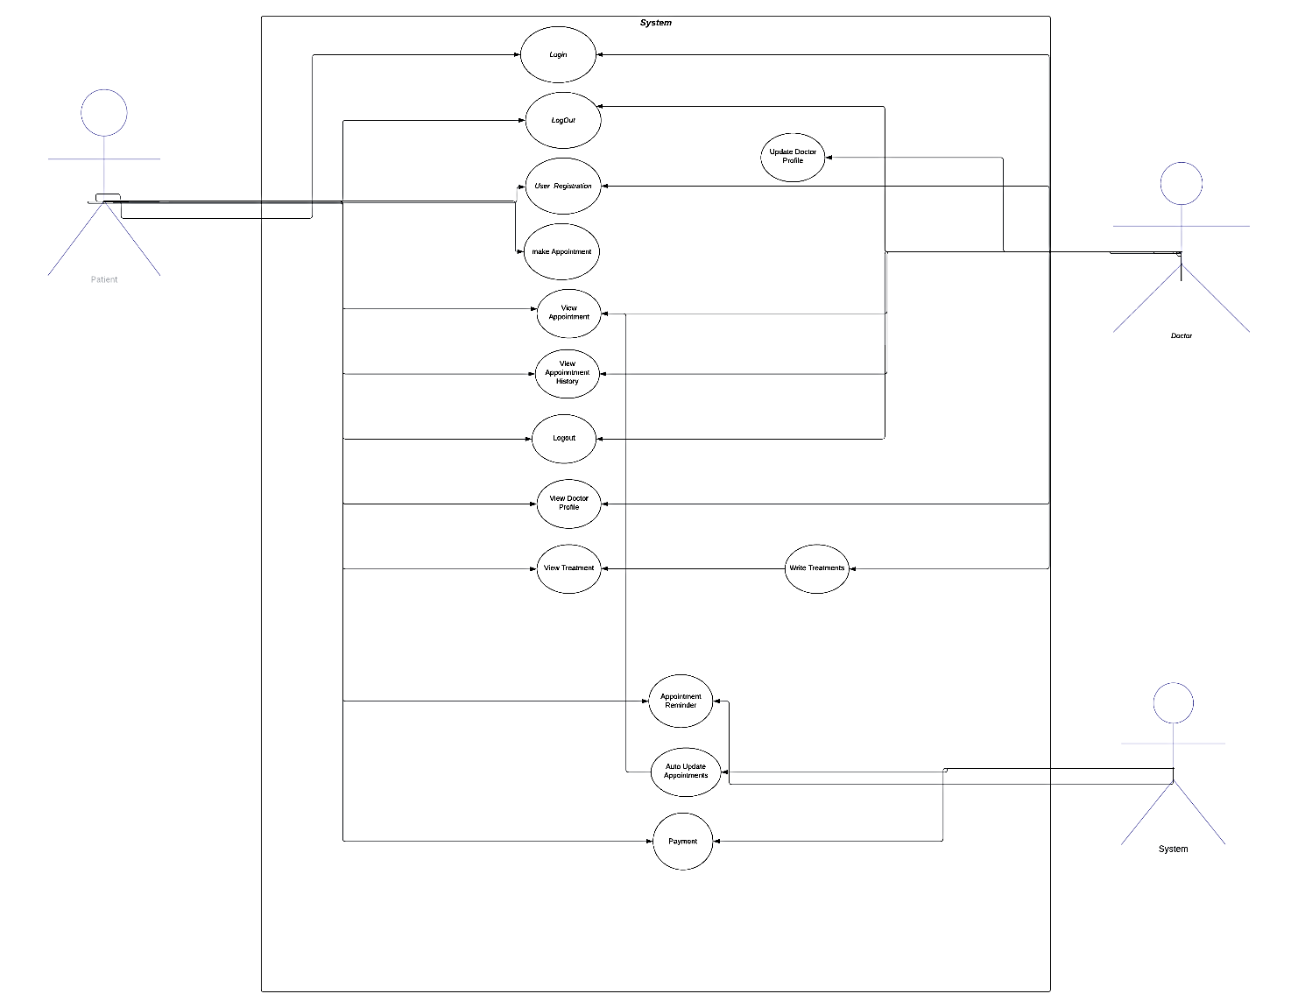

Fig. 3-1: Use case model

**3.3.2 Use Case Description**

Use Case 1: User Registration

Preconditions: The user has not registered on the platform.

Postconditions: The user's account is created, and they can log in.

Special Requirements: The user must provide valid registration details, including email, password, and personal information.

Use Case 2: User Login

Preconditions: The user is registered on the platform.

Postconditions: The user gains access to their dashboard.

Special Requirements: The user must provide valid login credentials, including email and password.

Use Case 3: Schedule Appointment

Preconditions: The user is logged in, and clinics and veterinarians are available.

Postconditions: An appointment is scheduled.

Special Requirements: The user selects a clinic, veterinarian, preferred date, and time for the appointment.

Use Case 4: View Vaccine History

Preconditions: The user is logged in, and pet health records are available.

Postconditions: The user can view the vaccine history.

Special Requirements: The user selects a pet to view the vaccine history.

Use Case 5: Manage Electronic Health Records (EHR)

Preconditions: The user is logged in, and pet health records are available.

Postconditions: The user can update and manage EHR.

Special Requirements: The user selects a pet to manage its EHR.

**3.4** **Design Diagram**

**System Overview:**

The architecture of the system (**Fig. 3-2)** is designed to facilitate interactions between various stakeholders, including pet owners, clinics, and veterinarians. Pet owners can access their pet's health records, schedule appointments, and receive reminders. Clinics can manage appointments, access pet health records, and update vaccine information. Veterinarians can view health records and manage appointments.

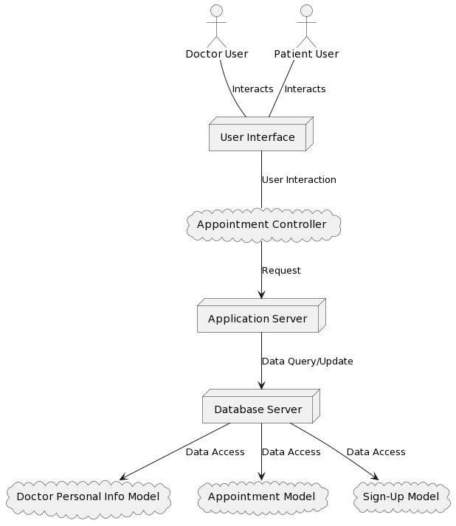

Fig. 3-2: Architecture model of the Website

**Architecture Description:**

User Interface (Presentation Layer):

* This layer includes distinct user interfaces for patients, doctors, and administrators.
* It provides the graphical user interfaces through which stakeholders interact with the application.

Application Logic (Business Logic Layer):

* The business logic layer contains the core functionality of the application.
* It handles appointment scheduling, user authentication, Auto Update Appointment Scheduling, Vaccine History, Appointment History, payment
* This layer ensures the application's functional and business requirements are met.

Data Storage (Data Access Layer):

* Data, including patient records, appointments, and user profiles, is stored in a MongoDB database.
* The data access layer manages interactions with the database, facilitating data retrieval, storage, and updates.

The layered architecture approach enhances the maintainability and scalability of the system. The system's stakeholders interact with their respective user interfaces, which, in turn, communicate with the business logic layer. The business logic layer interacts with the data storage layer to access and manipulate data

**3.4.2 Sequence diagrams**.

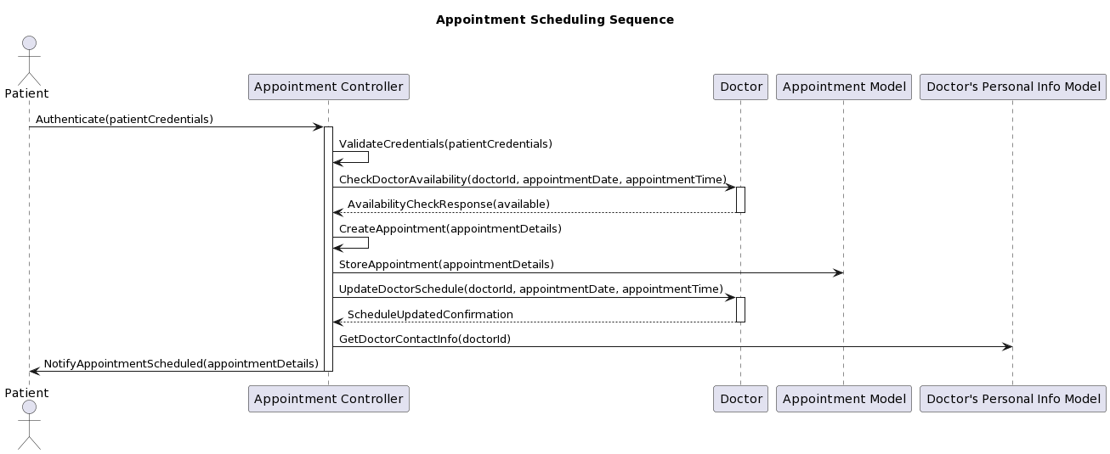

Fig. 3-3: Sequence Diagram for Appointment Scheduling

**Chapter – 4 Implementation and Testing**

**4.1**  **Database Design** 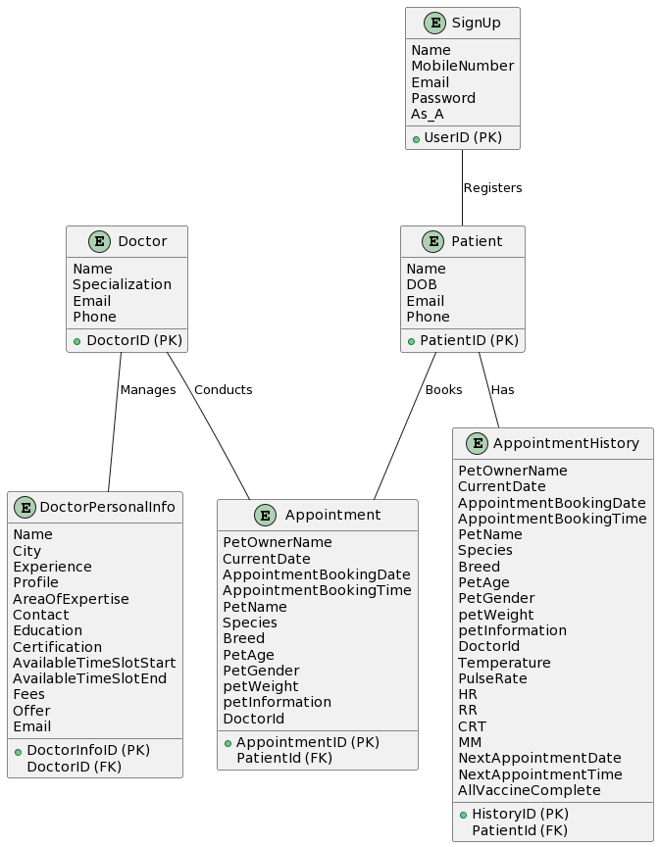

Has

Registers

Fig. 4-1:ER Diagram for Vet World

Table Structures:

DoctorPersonalInfomation Table:

PK: DoctorID

Fields: Name, City, Experience, Profile, AreaOfExpertise, Contact, Education, Certification, AvailableTimeSlotStart, AvailableTimeSlotEnd, Fees, Offer, Email

SignUp Table:

PK: PatientID

Fields: Name, MobileNumber, Email, Password, As_A

AppointmentSchema Table:

PK: AppointmentID

Fields: PetOwnerName, CurrentDate, AppointmentBookingDate, AppointmentBookingTime, PetName, Species, Breed, PetAge, PetGender, petWeight, petInformation, DoctorId (FK), PatientId (FK), Temperature, PulseRate, HR, RR, CRT, MM, NextAppointmentDate, NextAppointmentTime, AllVaccineComplete

AppointmentHistoryModel Table:

PK: HistoryID

Fields: PetOwnerName, CurrentDate, AppointmentBookingDate, AppointmentBookingTime, PetName, Species, Breed, PetAge, PetGender, petWeight, petInformation, DoctorId (FK), PatientId (FK), Temperature, PulseRate, HR, RR, CRT, MM, NextAppointmentDate, NextAppointmentTime, AllVaccineComplete

**4.2 Class diagram** :

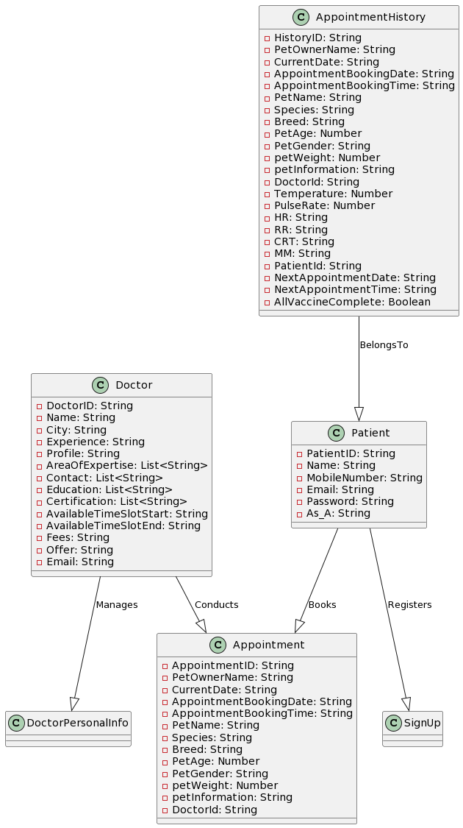

Fig. 4-2:Class Diagram for Vet World

Explanation:

The class diagram illustrates the structure of the system's classes and their relationships. In this project, classes represent entities and functional components of the application.

* User Class: Represents users with attributes like User ID, Username, Password, Email, and User Type. It provides methods for user registration, login, and profile management.
* Appointment Class: Models appointments, including attributes like Appointment ID, User ID, Clinic ID, Vet ID, Date, and Time. Methods allow scheduling, updating, and canceling appointments.
* Pet Class: Represents pets, including attributes like Pet ID, User ID, Pet Name, Species, Breed, and Age. It provides methods for adding and updating pet information.
* HealthRecord Class: Represents pet health records with attributes like Record ID, Pet ID, Vaccine History, and Medical Reports. It offers methods for updating and retrieving health records.

Working of Methods:

* User Class Methods: The "registerUser" method allows users to create an account by providing user details. The "loginUser" method verifies user credentials for authentication, and the "updateProfile" method lets users modify their information.
* Appointment Class Methods: The "scheduleAppointment" method enables users to book appointments, and the "updateAppointment" method allows them to make changes.
* Pet Class Methods: The "addPet" method facilitates the addition of pet details, and the "updatePetInfo" method is used for modifying pet information.
* HealthRecord Class Methods: The "updateHealthRecord" method is employed to add or update pet health records, including vaccine history and medical reports.

**4.3 Test Cases**

Testing Techniques:

* Unit Testing: Testing individual components, classes, and methods to ensure their functionality.
* Integration Testing: Testing interactions between various modules and components.
* User Testing: Involving actual users to assess the platform's usability and user-friendliness.

Test Cases with Snapshots:

Test 01 : Test case for successful Login

Login ID : shakshamneekhra96@gnail.com

Password : 123

System Output: Successful Login

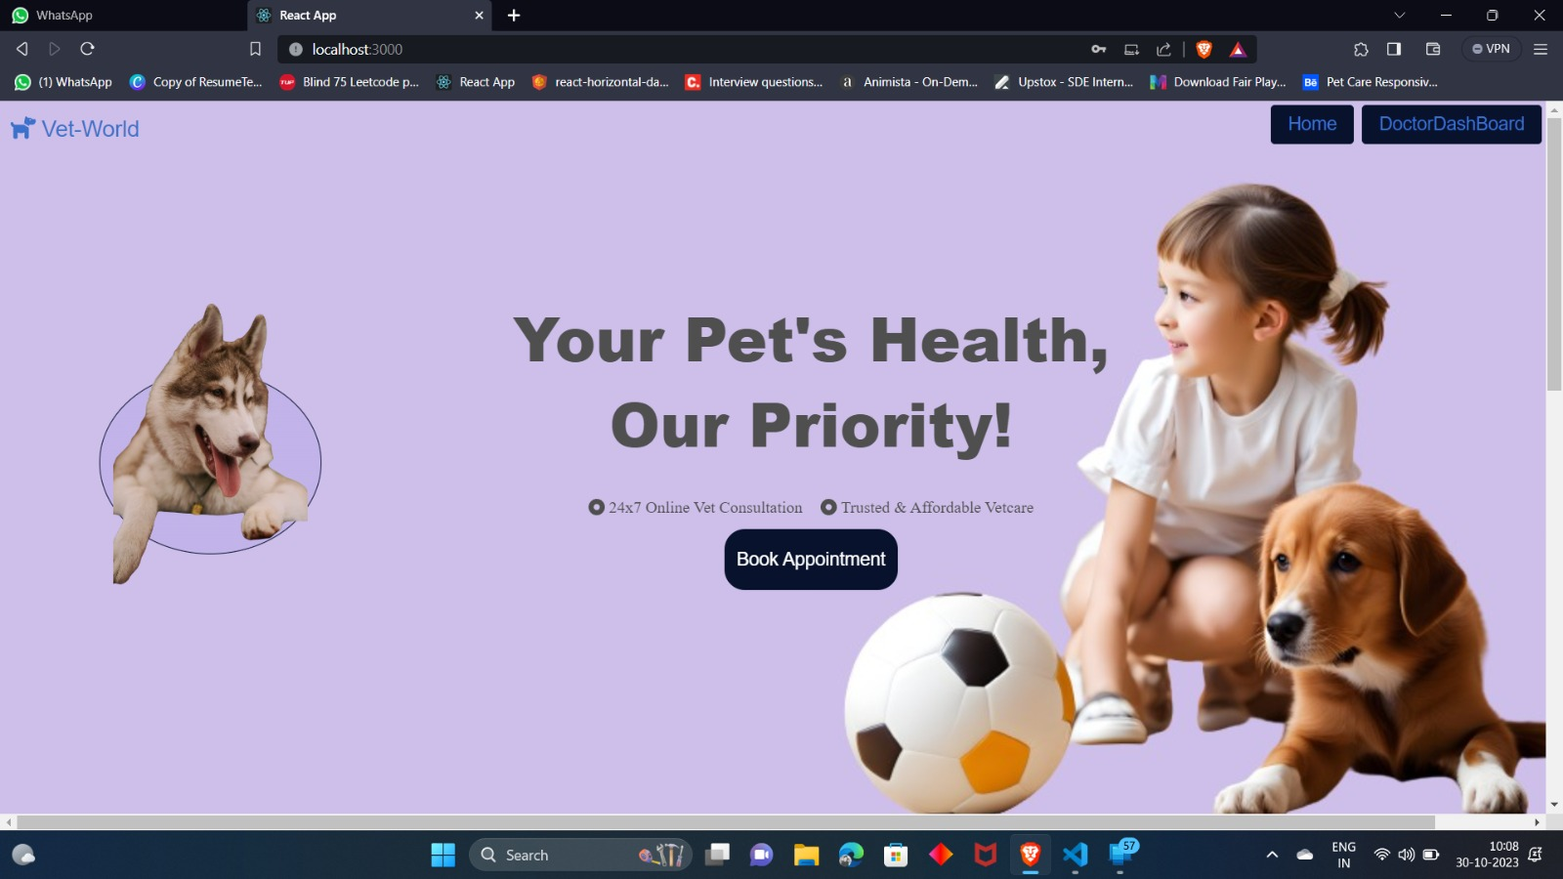

Test 02 : Test case for incorrect password

Login ID: shakshamneekhra96@gnail.com

Password: 124

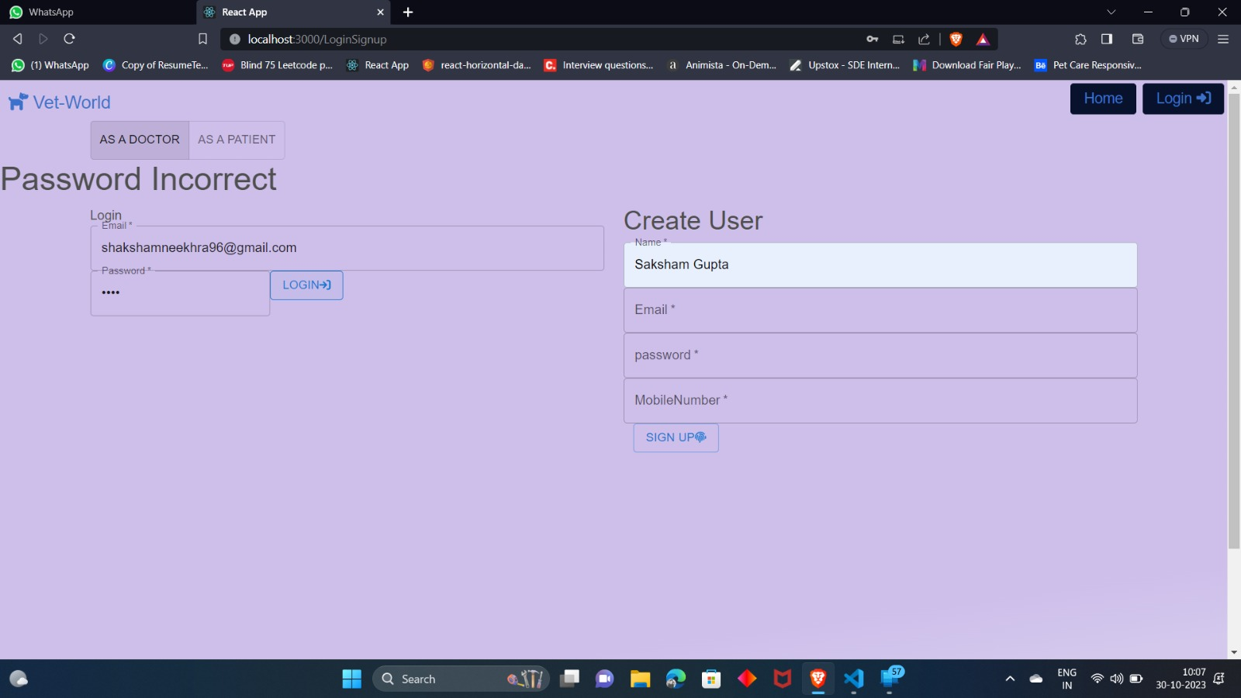System Output: Incorrect Password

Test 03 : Test case for incorrect ID

Login ID: shakshamneekhra96@gnail.com

Password: 123

System Output: Incorrect ID

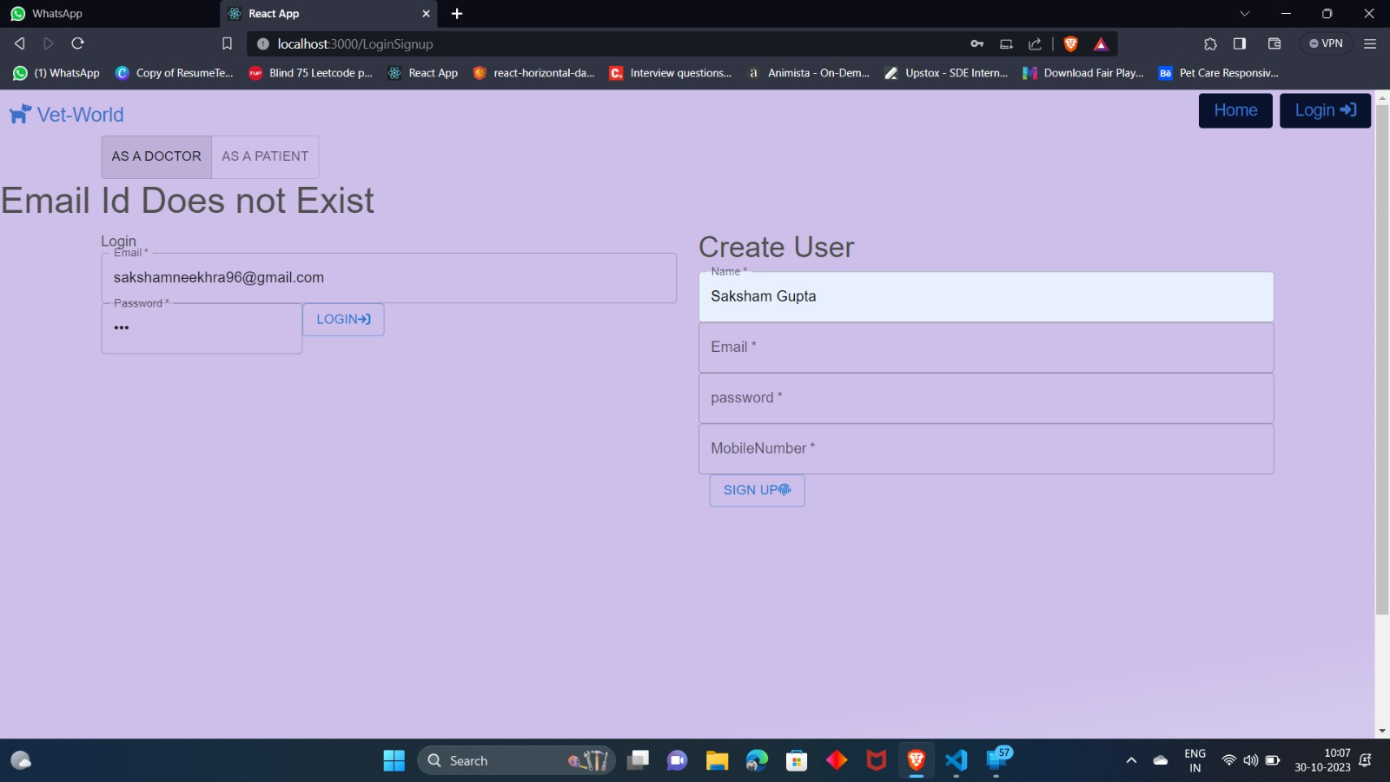

**Chapter – 5 Conclusion**

Learning and Achievements:

This project has provided invaluable learning experiences in web application development, database design, and system architecture. It allowed the practical application of software engineering concepts and real-world problem-solving.

Limitations:

* The project currently lacks video conferencing integration for telemedicine, which could be a valuable addition.
* Data security, although addressed, may require continuous monitoring for potential vulnerabilities.

Future Expansions:

* Future expansions may include integrating video conferencing capabilities for remote veterinary consultations.
* Enhanced user notifications and reminders for vaccination and wellness check-ups.
* The incorporation of AI-based diagnostic tools to aid veterinarians in diagnosing and treating pets.

This project has not only provided a functional and user-centric pet healthcare platform but also serves as a foundation for potential future improvements and enhancements in the field of veterinary services and pet care.

**REFRENCES**

1. "The Pet Nest." [Online]. Available: https://thepetnest.com/online-veterinary-service. [Accessed: Date, e.g., November 1, 2023].
2. "My Petz - Online Vet Consultation." [Online]. Available: https://mypetz.co.in/consult_services/online_vet_consultation. [Accessed: Date, e.g., November 1, 2023].
3. "Petofy - Pet Consultations in Gurugram (Gurgaon)." [Online]. Available: https://petofy.com/gurugram(gurgaon)/pet-consultations. [Accessed: Date, e.g., November 1, 2023].
4. "Petzz." [Online]. Available: https://petzz.org/. [Accessed: Date, e.g., November 1, 2023].
5. "VetEva - Consult a Vet Online." [Online]. Available: https://www.veteva.com/consult-a-vet-online/. [Accessed: Date, e.g., November 1, 2023].